Inner Diameter of a Cylinder
# Source: AI Source: Provided by: [Data Path: Persons Table -> ID Column: 1, Name_En Column: Motasem Essam] -> From: [ChatGPT] on [7/25/2026]
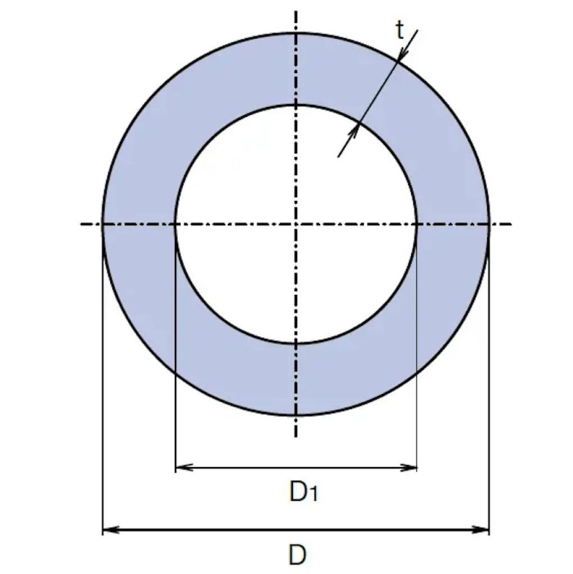
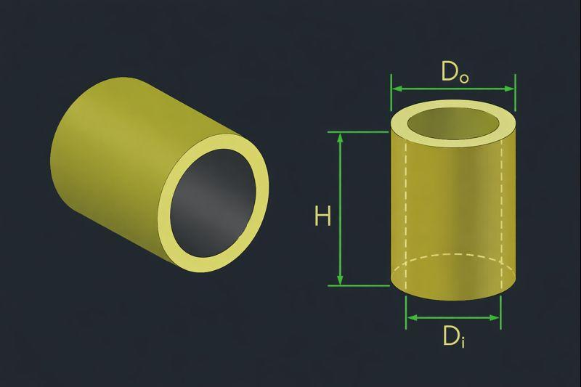
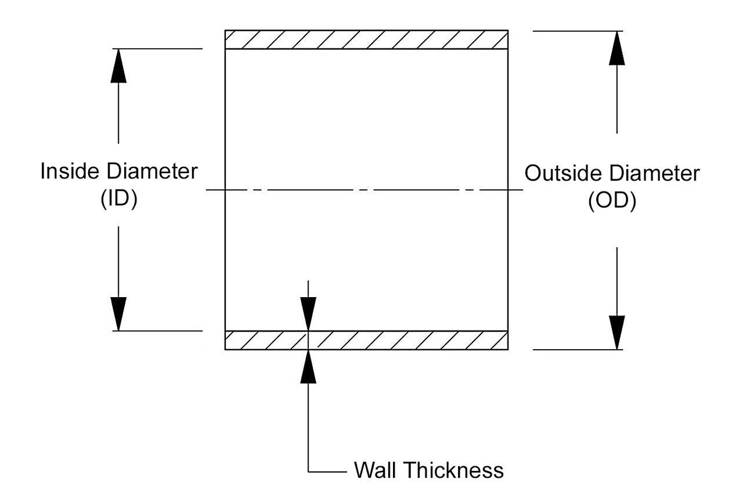

Definition
# Source: AI Source: Provided by: [Data Path: Persons Table -> ID Column: 1, Name_En Column: Motasem Essam] -> From: [ChatGPT] on [7/25/2026]
The inner diameter of a hollow cylinder is the distance across its internal circular opening, measured along a straight line passing through the center of the opening.
It is commonly represented by $D_{i}$ or $d_{i}$. The inner diameter describes the full width of the hollow region and is twice the inner radius.
$$\boxed{D_{i}=2r_{i}}$$
For a hollow cylindrical pipe, it measures the opening available for fluid flow or for an object to pass through.

Simple Definition
# Source: AI Source: Provided by: [Data Path: Persons Table -> ID Column: 1, Name_En Column: Motasem Essam] -> From: [ChatGPT] on [7/25/2026]
The inner diameter is the distance from one inside edge of a hollow cylinder to the opposite inside edge, measured through the center.

Geometric Representation
# Source: AI Source: Provided by: [Data Path: Persons Table -> ID Column: 1, Name_En Column: Motasem Essam] -> From: [ChatGPT] on [7/25/2026]
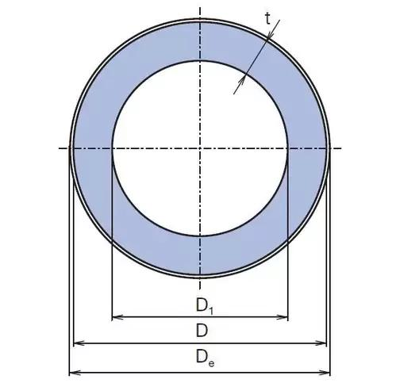
The main geometric components are:
- Inner circular boundary: the edge surrounding the hollow opening.
- Inner radius ($r_{i}$): distance from the center to the inner boundary.
- Inner diameter ($D_{i}$): distance across the opening through its center.
- Outer diameter ($D_{o}$): distance across the complete external boundary.
- Wall thickness ($t$): radial thickness of the cylindrical material.
For a hollow cylinder with positive wall thickness:
$$D_{i}<D_{o}$$

Mathematical Formulas

Inner Diameter from Inner Radius
# Source: AI Source: Provided by: [Data Path: Persons Table -> ID Column: 1, Name_En Column: Motasem Essam] -> From: [ChatGPT] on [7/25/2026]
$$\boxed{D_{i}=2r_{i}}$$

Inner Radius from Inner Diameter
# Source: AI Source: Provided by: [Data Path: Persons Table -> ID Column: 1, Name_En Column: Motasem Essam] -> From: [ChatGPT] on [7/25/2026]
$$\boxed{r_{i}=\frac{D_{i}}{2}}$$

Inner Diameter from Inner Circumference
# Source: AI Source: Provided by: [Data Path: Persons Table -> ID Column: 1, Name_En Column: Motasem Essam] -> From: [ChatGPT] on [7/25/2026]
The circumference of the inner circular opening is:
$$C_{i}=πD_{i}=2πr_{i}$$
Therefore,
$$\boxed{D_{i}=\frac{C_{i}}{π}}$$

Inner Diameter from Outer Diameter and Wall Thickness
# Source: AI Source: Provided by: [Data Path: Persons Table -> ID Column: 1, Name_En Column: Motasem Essam] -> From: [ChatGPT] on [7/25/2026]
For a hollow cylinder with uniform wall thickness \(t\):
$$D_{o}=D_{i}+2t$$
Rearranging:
$$\boxed{D_{i}=D_{o}-2t}$$

Area of the Inner Opening
# Source: AI Source: Provided by: [Data Path: Persons Table -> ID Column: 1, Name_En Column: Motasem Essam] -> From: [ChatGPT] on [7/25/2026]
$$A_{i}=πr_{i}^{2}$$
Using the inner diameter:
$$\boxed{A_{i}=\frac{πD_{i}^{2}}{4}}$$
This is the area of the empty circular opening, not the cross-sectional area of the material.

Material Volume of a Hollow Cylinder
# Source: AI Source: Provided by: [Data Path: Persons Table -> ID Column: 1, Name_En Column: Motasem Essam] -> From: [ChatGPT] on [7/25/2026]
For a straight hollow cylinder of height \(h\):
$$V=\frac{πh}{4}\left(D_{o}^{2}-D_{i}^{2}\right)$$
Rearranging to find the inner diameter:
$$\boxed{D_{i}=\sqrt{D_{o}^{2}-\frac{4V}{πh}}}$$
This formula applies when the outer diameter, height, and material volume are known and the dimensions describe a uniform hollow cylinder.

Worked Examples
# Source: AI Source: Provided by: [Data Path: Persons Table -> ID Column: 1, Name_En Column: Motasem Essam] -> From: [ChatGPT] on [7/25/2026]
Example 1: Finding the inner diameter from the radius
Given: Inner radius $r_{i}=6\text{ cm}$.
Solution:
$$D_{i}=2r_{i}=2\left(6\right)$$
Answer: $\boxed{D_{i}=12\text{ cm}}$
Example 2: Finding the inner diameter from the outer diameter
Given:
- Outer diameter: $D_{o}=30\text{ mm}$
- Wall thickness: $t=4\text{ mm}$
Solution:
$$D_{i}=D_{o}-2t$$
$$D_{i}=30-2\left(4\right)$$
Answer: $\boxed{D_{i}=22\text{ mm}}$
Example 3: Finding the inner diameter from circumference
Given: Inner circumference $C_{i}=18π\text{ cm}$.
Solution:
$$D_{i}=\frac{C_{i}}{π}=\frac{18π}{π}$$
Answer: $\boxed{D_{i}=18\text{ cm}}$
Example 4: Finding the inner diameter from material volume
Given:
- Outer diameter: $D_{o}=10\text{ cm}$
- Height: $h=12\text{ cm}$
- Material volume: $V=192π{\text{ cm}}^{3}$
Solution:
$$D_{i}=\sqrt{D_{o}^{2}-\frac{4V}{πh}}$$
$$D_{i}=\sqrt{100-\frac{4\left(192π\right)}{12π}}$$
$$D_{i}=\sqrt{100-64}=\sqrt{36}$$
Answer: $\boxed{D_{i}=6\text{ cm}}$

Key Characteristics
# Source: AI Source: Provided by: [Data Path: Persons Table -> ID Column: 1, Name_En Column: Motasem Essam] -> From: [ChatGPT] on [7/25/2026]
- The inner diameter measures the width of the hollow opening.
- It passes through the center of the inner circular boundary.
- It equals twice the inner radius.
- It is smaller than the outer diameter when the cylinder has positive wall thickness.
- It determines the cross-sectional area available for fluid flow through a circular pipe.
- The inner diameter alone does not determine the outer diameter or wall thickness.

Comparison with Related Measurements
# Source: AI Source: Provided by: [Data Path: Persons Table -> ID Column: 1, Name_En Column: Motasem Essam] -> From: [ChatGPT] on [7/25/2026]
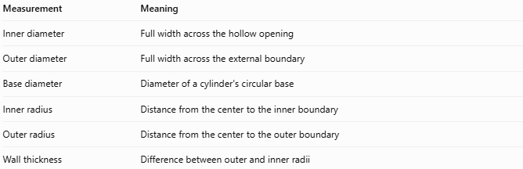
Measurement | Meaning
Inner diameter | Full width across the hollow opening
Outer diameter | Full width across the external boundary
Base diameter | Diameter of a cylinder's circular base
Inner radius | Distance from the center to the inner boundary
Outer radius | Distance from the center to the outer boundary
Wall thickness | Difference between outer and inner radii
Important distinction: For a solid cylinder, the central cross-section is filled, so there is no hollow opening and no inner diameter in the usual sense. The inner diameter is primarily relevant to hollow cylinders, pipes, and tubes.

Applications
# Source: AI Source: Provided by: [Data Path: Persons Table -> ID Column: 1, Name_En Column: Motasem Essam] -> From: [ChatGPT] on [7/25/2026]
- Plumbing: determines the internal opening of pipes.
- Fluid mechanics: helps calculate flow area and fluid velocity.
- Mechanical engineering: specifies the bore of hollow shafts and sleeves.
- Manufacturing: controls the internal dimensions of tubes and cylindrical components.
- Construction: describes hollow structural members.

Key Points
# Source: AI Source: Provided by: [Data Path: Persons Table -> ID Column: 1, Name_En Column: Motasem Essam] -> From: [ChatGPT] on [7/25/2026]
- Symbol: $D_{i}$
- From inner radius: $D_{i}=2r_{i}$
- From inner circumference: $D_{i}=C_{i}/π$
- From outer diameter and wall thickness: $D_{i}=D_{o}-2t$
- Area of the opening: $A_{i}=πD_{i}^{2}/4$

Conclusion
# Source: AI Source: Provided by: [Data Path: Persons Table -> ID Column: 1, Name_En Column: Motasem Essam] -> From: [ChatGPT] on [7/25/2026]
The inner diameter is a fundamental measurement of a hollow cylinder, describing the full width of its internal opening. It is closely related to the inner radius, outer diameter, and wall thickness, and is essential for calculating the available flow area and other geometric properties of hollow cylindrical objects.

